
Beginners practical:
Development of a computer game

Leonard Gallus, Paul Horn, Eric Waldherr

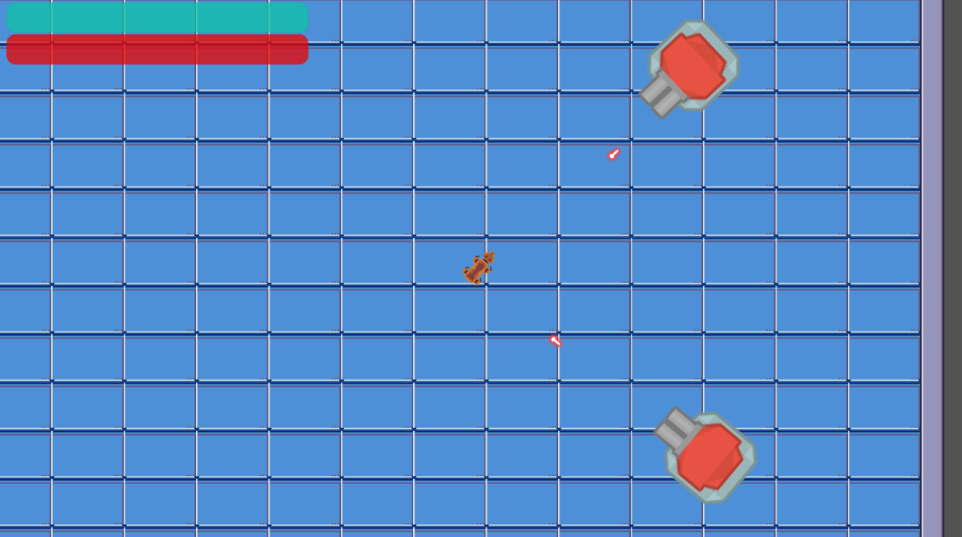

Supervisor: Jürgen Hesser

Table of contents
1 Introduction and Basics 3
2 Use Case, Requirements Analysis and Architecture 4
2.1 Use cases 4
2.2 Requirement Analysis 5
2.3 Architecture 6
3 Implementation 7
4 Development Process 9
4.1 Test-Driven Development 9
4.2 Prototyping 10
4.3 Improvements to the development process 12
5. Conclusion 15
6 Appendix 16
6.1 First Requirement Analysis 16
6.2 Final Requirement Analysis 19
6.3 Storyboard 23
6.4 Doxygen Generated File.......................................................................24

1 Introduction and Basics

The aim of the internship was to design and implement an agile development process for the development of a computer game. The process was built and implemented based on the SCRUM model. The focus was also on improving our own development process to ensure error-free development.
For this, the Godot engine was used. We chose this engine because we wanted to design a 2D top-down shooter, which is beginner-friendly to design with Godot. This was important to us because we had no experience working with engines before the internship.
Due to the many complex functionalities that were not necessary for our project, we decided against the use of larger engines like Unity or Unreal Engine. An important criterion for using Godot is the intuitive level design, which is easy to understand and use. Furthermore, classes that were necessary for our project were already implemented. For example, there is a class for entities we could use for the player and the enemies. Additionally, there are also classes that can be used for collectible items and projectiles.
The following chapters describe in detail how we met the requirements and goals and also how we adapted and improved the development process along the way.

2 Use Case, Requirements Analysis and Architecture

Before going into more detail about the individual documents created during development, the concept, plot and goal of the game will be briefly summarized.
The game, which is designed for one player, is about a robot dog, named L41k4, who wakes up in the Heidelberg Dynamics research facility and tries to escape from it.
On the way out, various hurdles must be overcome, such as locked doors and enemy turrets. L41k4 has a built-in weapon available to fight off these enemies encountered in the facility. The game uses a 2D top-down perspective with textures designed in pixel art style. Music with appropriate sound effects runs in the background and during fights. The final level features a special enemy type that is stronger than the usual enemies. After beating this level, the player escapes the facility and, by that, wins the game. If the player's health, which is shown inside of a HUD, reaches zero, an appropriate dialogue is shown and the player can choose to restart the game or close it.

2.1 Use cases

If you look closely at the use case diagram, you will see that the player controls the character L41k4. This allows the player to collect key cards that are needed to open the doors that lead to the next level. The player can fire projectiles that reduce the life points of opponents if hit. The enemies can also shoot projectiles that can hit the player. If the player's life points fall to zero, an appropriate dialogue is shown. There is a boss enemy type that appears in the final level. Defeating this enemy will lead to the escape of the player out of the facility and the game ends.
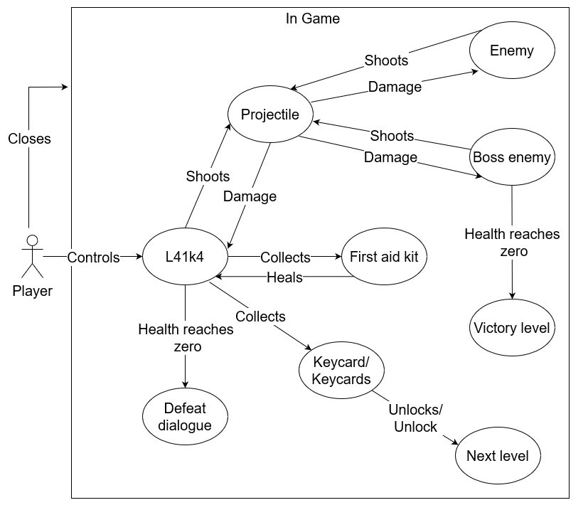Figure 1: Use Case Diagram

2.2 Requirement Analysis

The use cases just described, result in the requirements displayed in the appendix, which can also be found in the requirement analysis. We divided the requirements into functional and nonfunctional requirements.
While looking at the functional requirements, it is clear that we first laid down very fundamental requirements. This included the basic movement of the player through the levels. We decided that each level features enemies that can shoot projectiles at the player to stop his endeavors. The player can also shoot back. These projectiles get destroyed when they hit another object. The projectiles can also hit and damage entities. These actions are implemented by a health system that manages the health and damage of each entity in the game. During the run, the player can find and collect first aid kits that heal the player's health. To stop the player from only running through each level while avoiding the enemies, we decided to add keycards to each level. These are required to unlock the next level and are guarded by enemies. This should bring more life to the game and make it more challenging. When the player's health reaches zero, a dialogue appears and the player can restart or exit the game.
The use cases also led to many nonfunctional requirements. One of the main goals here was to provide the player with essential information during a playthrough. This includes a HUD that is visible to the player at all times. The HUD is made up of a health- and shieldbar that indicates the player's health condition and is updated when any changes occur. Furthermore, a keycard symbol appears for every keycard that the player collects within a level. That way, the player knows when they can proceed to the next level.
Another aspect is the audio of the game. It consists of a main theme that runs in the background at all times. In addition to that, there are sound effects when a projectile is shot as well as when an entity is hit. These sound effects support the overall feel and look of the game.

2.3 Architecture
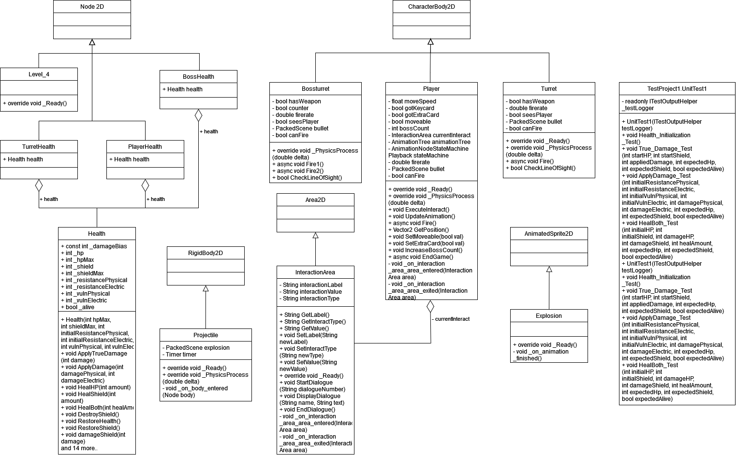Figure 2: Class Diagramm
In order to meet these requirements, the following architecture was developed for the game. Godot already provided us with the classes StaticBody2D, RigidBody2D and CharacterBody2D. These were the main classes we used to implement our entities for the game. For the collectible keycards and first aid kits of our game, we used the class StaticBody2D. As this superclass already implemented all necessary attributes and functions, the classes we designed do not have any complex new features.
The projectile class of the game was implemented, inheriting from RigidBody2D. This class provides functions for detecting collisions with other objects, which was crucial for us.
We used the functionality of CharacterBody2D to realize our Player class as well as the enemy types. These entities also need a health, which is the reason why they have an instance of the Health class as an attribute. This class manages the health, damage and healing of each individual entity.
The Player class and the collectibles each own an object of the type InteractionArea. This class is used for detecting the overlapping of different areas and then enabling certain interaction features, such as picking up a keycard.
The dialogues of the game are also realized with an InteractionArea that detects when the player enters a certain room and then triggers a dialogue that is shown and executed by the DialogueManager which is an attribute of an InteractionArea.
All of these objects and entities belong to a certain level, where they all have their individual position. Each level manages an object of the class HUD that you can find at the top left of the screen at all times. It displays the health and shield of the player. It also has an object of the Godot class Camera2D, which ensures that the player is in the middle of the screen throughout the whole playthrough. However, the two classes HUD and Camera2D are not represented in the class diagramm. This is the case due to the fact that Godot allowed us to implement this functionalities without actually writing code.
This architecture led to the implementation described in detail in the next chapter below.

3 Implementation

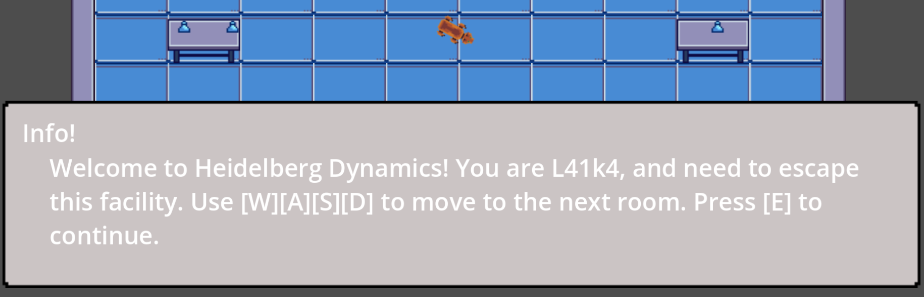Figure 3: Illustration of the Dialogue System
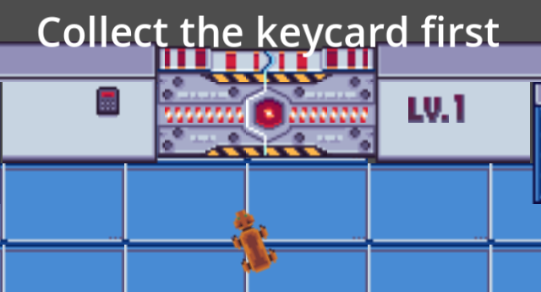Figure 4: Interaction between objects

The last chapter focused on the requirements and the architecture. This chapter describes how this is implemented into the game in detail. The player class is structured as follows: The main function of the player and all other entities is the _PhysicsProcess(double delta) function. This function executes for every tick of the game. In the first part of this function, we process all the inputs applied from the player and move the main character accordingly. Here it is also checked if the player interacts with its environment.
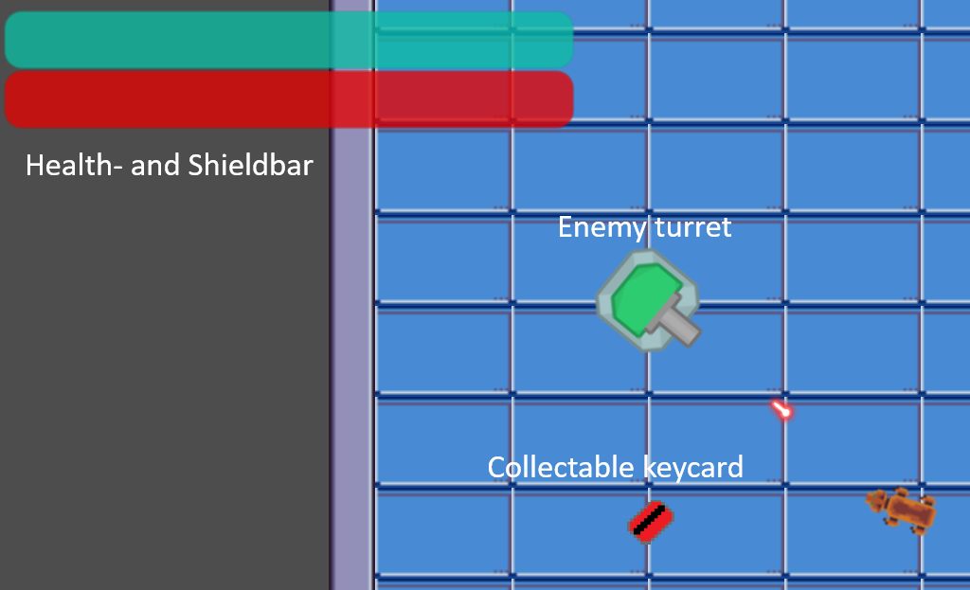Figure 5: Illustration of different game aspects
The enemy classes are built by utilizing the same function. Here, the enemy aims at the current position of the player and then fires at a fixed fire rate.
When an entity fires a projectile, a new instance of the projectile class is created and set to the position of the entity that fires the bullet. Additionally, the bullet gets a vector that is based on the direction the firing entity is facing. The projectile flies in that direction until it either hits another object or an assigned timer that limits its lifetime runs out.
To enable the feature of actually damaging entities, the health system needed to be implemented. This is found in the game-systems directory and is the essential code base of the game. Therefore, the most test functions are found here and every non-trivial function of the health system is thoroughly tested. The health system features two types of damage: physical and electrical. These damage types have their respective resistances and vulnerabilities that are assigned to an entity, making it especially resistant or vulnerable to a damage type. The rest of the health class features several methods that cover all the different cases, such that the applied damage to a character's health and shield is calculated correctly.
Keycards and first aid kits can be collected by the player but do not provide any complex functions themselves. The challenge here lies in the detection of when the player is in range to pick them up. For that, we implemented a class called InteractionArea. This class inherits from the Area2D class of Godot and, for that reason, provides signal functions when its area is entered or left by another entity. To be able to distinguish which type of area is entered (i.e. keycard or first aid kit), the InteractionArea class features three essential string variables: type, value and label. Type describes whether the InteractionArea belongs to a keycard, first aid kit, dialogue or serves another purpose. The label is a text that is shown to the player as soon as they are in range to interact with the object the InteractionArea belongs to. As we also assign InteractionAreas to doors to be able to reach the next level, the value determines which level needs to be loaded next or which dialogue needs to be displayed in the case the InteractionArea belongs to a dialogue.
To enable all these different components to interact with each other, they are all added to the same scene. Each scene represents a level and the needed amount of instances of each class can be added to the levels as children. This is the common way to create a game environment using Godot. It also features a TileMap. The TileMap determines the layout of the level, i.e. where walls and other objects the player can collide with are placed.
Many of the described features also produce a sound, as described in the requirement analyses. To add this to the game, we added AudioStreamPlayers to the different classes and played them when the appropriate action takes place.

4 Development Process

Before looking at the development of the process, the structure of the given process is examined.

4.1 Test-Driven Development

The most important aspect of development is Test-Driven Development (TDD). This principle is essential as the goal of the internship is to develop an agile process for the creation of a videogame that achieves a 0-error level. It is incredibly helpful to have tests that check whether the new changes made lead to the occurrence of errors. In addition to that, creating tests for classes or methods before actually implementing them forces the developer to think carefully about the code they are about to write. This prohibits a large amount of errors before they can cause problems. While implementing this strategy, we ran into many difficulties. First of all, we checked how to include unit tests in the structure of the Godot engine. For that, there are different addons that allow the creation of unit tests directly within the engine. After utilizing one of these addons, we noticed that most of the functions written directly inside of Godot simply set different variables provided by the engine itself. This leads to an insufficient complexity of these functions for test purposes. That led to the decision to outsource the more complex systems that we planned for the game to Visual Studio Code (VSC). In VSC, the creation of unit tests is well supported, but obviously the Godot-script-language that we used until that point for coding is not. Additionally, the Godot-script-language is not sufficient for writing complex structures, which was necessary for our project. For that reason, we decided to change all of the code into the C# programming language. After resolving these initial issues, we could eventually integrate Test-Driven Development into our development process. The testing itself worked without bigger problems, but in some cases we did not cover all the important test cases, i.e. testing off-by-one errors. We added these tests later in the development process and decided to think about possible test cases more carefully for the future.
Even though Test-Driven Development helped us in many ways during the course of the internship, the unit tests do not cover all aspects of testing. We faced multiple occasions during the internship where all the tests ran through successfully, but while playing the game, bugs or unexpected behavior occurred. Those errors were connected to the engine itself and were often caused by wrong assumptions about the behavior of the game engine while coding. This led to the conclusion that we needed some additional integration tests to verify if the produced code actually leads to the expected behavior. This meant that after implementing a requirement, we then started the game and tested the new feature. This improved our testing process even further. Overall, Test-Driven Development is a fundamental concept and was important to us.

4.2 Prototyping
Another strategy that was integrated into the given development process was Prototyping. Prototyping should be used whenever it is unclear how to fulfill a requirement or the code itself. This was especially helpful in the beginning of the internship, as we did not have any experience with working with game engines. Due to that, we had to try out many different classes and interfaces of the engine to find out what suits our requirements best, leading to the creation of many prototypes at the start of our project. But also in the later stages of the game, we faced situations where it was unclear how to proceed in order to fulfill certain requirements. Overall, the prototyping strategy was very useful for us and we found that it is a very intuitive step when facing issues or when making crucial decisions.
To organize the game development, we hold SCRUM meetings every week. These meetings included every team member telling what they achieved over the last week and what difficulties they faced. After that, we discussed if we should adapt our development process to avoid these difficulties in the future. Finally, we assigned tasks for each individual team member for next week. This includes a time estimation for each task. We noticed that this estimation was rather difficult and the estimations rarely fit the actual time needed.

4.3 Improvements to the development process

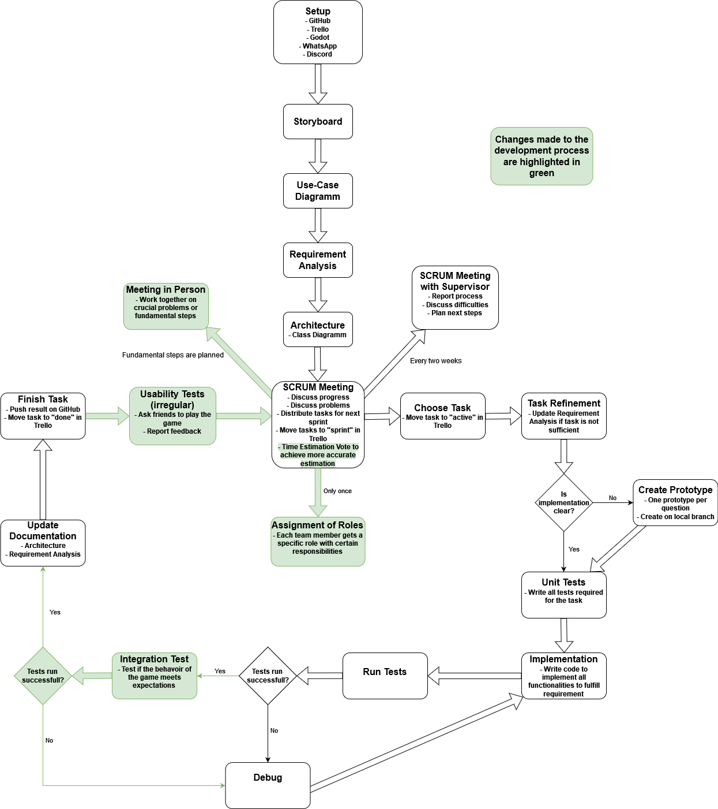Figure 6: Agile Development of our Process
This leads us to the improvements we implemented into the development process. To resolve the issues we had with the time estimation, we added a voting process. This process works as follows: After assigning a task to a team member, the whole team casts a vote on how much time this individual task will consume. If the different votes differ significantly, a discussion followed to analyze the more thoroughly, leading to a new time estimation every member more or less agrees with. That way, every member is included in this process for every task instead of every member estimating their own tasks. Even though this improvement led to longer SCRUM meetings, because every task where the time estimation was unclear led to a short discussion. But after using this technique for a longer time, it became clear that this had a positive impact on the time evaluation. The error when estimating the need time became much smaller than they were before marking this as a successful improvement to the development process. Additionally, this also allowed us to assign a more appropriate number of tasks to each team member per week. Eventually, we had fewer cases of a team member not finishing all of their assigned tasks, which made the whole process more structured.
In the beginning of the internship, we noticed that our whole work structure is too unstructured and it was often unclear which team member is responsible for certain tasks. For that reason, we created three roles and assigned one of them to each team member. The three roles can be described as follows: The first role is responsible for creating and maintaining the GitHub repository and the Trello, as well as resolving issues with those systems as soon as any occur. The second role was responsible for the inner team communication. This included creating and maintaining a Discord server as well as a WhatsApp group. Additionally, this person plans the time and place of the next SCRUM meeting. The third role is leading the team intern SCRUM meetings and creating a protocol for each of those meetings. Additionally, this person is responsible for the communication with the supervisor of the internship.
Assigning these roles made it very clear to each member what their responsibilities are. This avoids unnecessary communication as the tasks of every member are fixed. Even though this seems unnecessary for this small group size we are working in, this change improved the overall structure and efficiency of the process.
As the next issue, we noticed that we all had little to no experience with game engines. For that reason, we all needed to learn the basics of working with Godot before even starting developing the game. Therefore, we all needed to do the same basic steps in the beginning. We determined that it is significantly more efficient to learn these steps together, due to the fact that if one member understands a fundamental functionality of Godot, he can share this knowledge with the other members. After doing this for the fundamental concepts of Godot, we saw huge potential in that work strategy and decided to implement this concept into our development process. In detail, we included an additional step to our SCRUM meetings after assigning the tasks for the next sprint. During this step we look at the tasks together and discuss if any of them include learning a fundamental concept of Godot that every team member needs to understand or if it includes an essential step of the game development. If that is the case, we determine a date where we meet in person to work on the problem together. These meetings in person ensure that every team member is on the same page regarding the stage of development of the game or features and concepts of Godot. This is essential for critical development steps. In addition to that, if a problem occurs and important decisions need to be made, the whole team is in the same room and can discuss solutions immediately. There are disadvantages to this concept as well. For example, an additional meeting needs to be held that week, requiring all members to have time to be present. The fact that all team members work on the same problem can also be an overhead. After implementing this concept, we decided to keep it as we saw that working on fundamental problems together can decrease the time needed to solve these major issues significantly. Most of the time, this included some concepts that every team member needs to understand at some point. So for us, these meetings barely were an overhead and overall helped us getting to know Godot and developing the game.
During the later stages of development, we tested the features of the game a lot of times and therefore were very familiar with all the aspects of the game. This made it challenging to determine whether a specific level or sequence of the game is too hard or too easy for new players. To be able to balance the game in a way that it is an enjoyable experience for first-time players, we decided to ask fellow students to test the game for us. We implemented this concept into our development process as follows: Every time we added a new feature to the game or designed a new level, we asked friends to play. During their playthrough, we observed them carefully to find out how to balance and improve the new features and the game itself. After that, we asked them for positive and negative feedback and noted the results. The only downside of this was that finding people and letting them play the game can be very time consuming. After including this step in the development process, we found it much simpler to improve the game with the different opinions on the different game features we gathered.

5. Conclusion

We faced many difficulties during the course of the internship, which led to the loss of a lot of time. Especially working with a game engine for the first time was a challenging experience. But eventually, we could learn from these errors and evolve our development process. That way we were able to achieve an agile development process for a computer game that fulfills most of the requirements stated in the requirement analysis. We also minimized the errors made during the development itself, leading to an almost error-free development in the end. With our current process and all the lessons learned in mind, we can plan and execute future projects more efficiently. This marks a huge success of the internship for us and we are confident that we have learned how to avoid many errors in the future.

6 Appendix

6.1 First Requirement Analysis
1. Introduction

1.1. Purpose of the system

The system is used for entertainment of the user. It is supposed to be a challenging experience which forces the player to evolve his skills and navigate carefully through the environment of the game.

1.2. Scope of the system

The System is quite small as it is only used for educational purposes and to get used to the processes of developing a video game.

1.3. Objectives and success criteria of the project

The objective of the project is to create a small video game with at least a playable level and a completely planned out and structured development.

1.4. Definitions, acronyms, and abbreviations

The playable character is named "L41k4".
The research facility is named "Heidelberg Dynamics"

2. Proposed system

2.1. Functional requirements

2.1.1 Movement
The player is required to be able to move the playable character throughout the levels.
2.1.2 Aim
The player character should be able to aim using the mouse.
2.1.3 Interaction with environment
The player character should move throughout a level, interacting with the environment. e.g. bump into a wall, walk down a corridor, etc. (Collision).
2.1.4 Health System
The game features a health system that manages all the damage and health variables of all entities in the game.
The playable character and the enemies have a certain number of hitpoints.
When the hitpoints of a entitiy run out, the character is eliminated.

2.1.5 Projectiles
Projectiles get destroyed when colliding with another object (i.e. walls, shelves, etc.).
2.1.6 Weapon
The game is required to have a useable weapon which the player can use to reduce the hitpoints of enemies.
2.1.7 Enemies
There have to be different enemies.
The enemies can attack and damage the player.
The player must also be able to defeat these enemies with a certain amount of attacks.
2.1.8 Keycards
There are keycards the player can collect in each level.
To complete a level the player must be able to collect the keycards first.
2.1.9 End of the game
The player can win the game by finishing all levels.
The player can loose the game when their hitpoints reach zero.

2.2. Nonfunctional requirements

2.2.1. User interface and human factors

2.2.1.1 User interface
The game features a health and a shield bar that is visible through a HUD to the player at all times.
After defeat, the player can restart the game.
The program can be closed.
2.2.1.2 Human factors
The controls of the game can be learned quickly

2.2.2. Documentation

There should be a documentation of at least the most important diagrams that help to understand the concept of the game in detail and as a whole. (see 2.5)
There should be a short documentation of all SCRUM meetings.
There should be a documentation of changes made in the development process.

2.2.3. Hardware considerations

A standard quality PC

2.2.4. Performance characteristics

The game should run smoothly and resposively.

2.2.5. Error handling and extreme conditions

Errors and exceptions should be logged and reported to the developers.

2.2.6. Quality issues

All the code is written in Chromium coding style.
We use line breaks after 80 characters.
We always use Test-Driven Development.
A class has a maximum of 200 LOC.

2.2.7. System modifications

There is just a log used for error handling.

2.2.8. Physical environment

There is no internet connection required to play the game.
There is a mouse and keyboard needed to play the game.

2.2.9. Security issues

Due to the fact that the game uses no internet connection and no data from the player so there should be no security issues.

2.2.10. Audio

The game features its own soundtrack and soundeffects.

6.2 Final Requirement Analysis
1. Introduction

1.1. Purpose of the system

The system is used for entertainment of the user. It is supposed to be a challenging experience which forces the player to evolve his skills and navigate carefully through the environment of the game.

1.2. Scope of the system

The System is quite small as it is only used for educational purposes and to get used to the processes of developing a video game.

1.3. Objectives and success criteria of the project

The objective of the project is to create a small video game with at least a playable level and a completely planned out and structured development.

1.4. Definitions, acronyms, and abbreviations

The playable character is named "L41k4".
The research facility is named "Heidelberg Dynamics"

2. Proposed system

2.1. Functional requirements

2.1.1 Movement
The player is required to be able to move the playable character throughout the levels with a fixed movement speed. WASD for up, down, left, right.
2.1.2 Aim
The player character is able to aim using the mouse.
The character aims in the cursor direction at all times.
2.1.3 Interaction with environment
The player character is able to move throughout a level, interacting with the environment. e.g. bump into a wall, walk down a corridor, etc. (Collision).
2.1.4 Health System
The game features a health system that manages all the damage and health variables of all entities in the game.
The playable character and the enemies have a certain number of hitpoints.
When the hitpoints of a entitiy run out, the character is eliminated.
The health and shield of the entities is limited between two values that are immutable.
There are two types of damage each entity type has: physical and electric.
There are resistance and vulnerbility stats for each entitiy for the different damage types.
2.1.5 Projectiles
Projectiles have a limited range. This is realized by a timer that destroys the bullet when it runs out.
Projectiles get destroyed when colliding with another object (i.e. walls, shelves, etc.).
When two projectiles collide they cancel each other out.
All projectiles travel with a fixed speed in a straight line.
2.1.6 Weapon
The game is required to have a useable weapon. The player can use the weapon to fire Projektiles that reduce the hitpoints of enemies.
The weapon has a fixed firerate.
2.1.7 Enemies
There have to be different enemies.
The enemies can attack and damage the player.
The player must also be able to defeat these enemies with a certain amount of attacks.
There is a enemy type "turret" that aims at the player and shoots projectiles at them.
There is a enemy type "bossturret" that aims at the player and shoots projectiles at them but at a significant faster pace than the normal "turret".
The enemies aim at the location of the player at all times.
The enemies shoot at a fixed firerate.
The turrets start shooting at the player as soon as they enter a certain range.
2.1.8 Keycards
There are keycards the player can collect in each level.
To complete a level the player must be able to collect the keycards first.
2.1.9 First Aid Kits
There are first aid kits that replenish the player's health and shield.
First aid kits are collected as soon as the player enteres their collision zone.
2.1.10 End of the game
The player can win the game by defeating the two bossturret enemies in the last level.
The player can loose the game when their hitpoints reach zero.

2.2. Nonfunctional requirements

2.2.1. User interface and human factors

2.2.1.1 User interface
The game features a health and a shield bar that is visible through a HUD to the player at all times.
The game contains a indicator that shows the player if they already collected all keycards of the current level.
After defeat, the player can restart the game with a press of a button.
The program can be closed with the press of a button.
2.2.1.2 Human factors
The controls of the game can be learned by the within 3 minutes.

2.2.2. Documentation

There should be a documentation of at least the most important diagrams that help to understand the concept of the game in detail and as a whole. (see 2.5)
There should be a short documentation of all SCRUM meetings.
There should be a documentation of changes made in the development process.

2.2.3. Hardware considerations

A PC with at least Windows 10 or a contemporary GNU/Linux variant,
At least 2 GB RAM
At least a GTX 750 or equivalent GPU
At least 2 GB of SSD Storage
At least a Ryzen 3 1200/Core i5-5200U or equivalent.

2.2.4. Performance characteristics

The game should run with at least 30 FPS.
A reaction to input should happen within 30 ms.

2.2.5. Error handling and extreme conditions

Errors and exceptions should be logged and reported to the developers.

2.2.6. Quality issues

All the code is written in Chromium coding style.
We use line breaks after 80 characters.
We always use Test-Driven Development.
A class has a maximum of 200 LOC.

2.2.7. System modifications

There is just a log used for error handling.

2.2.8. Physical environment

There is no internet connection required to play the game.
There is a mouse and keyboard needed to play the game.
There are no accessibility settings due to the games short development time.

2.2.9. Security issues

Due to the fact that the game uses no internet connection and no data from the player so there should be no security issues.

2.2.10. Audio

The game features its own soundtrack that is running in the background during the playthrough.
There is a sound effect when the player shoots a projectile.
There is a different sound effect when enemies shoot projectiles.
There are sounds when the player is hit.
There are sounds for hitting enemies.

2.3. Pseudo requirements

The game should feel smooth and responsive at all times.
The game is designed in pixelart.
All levels and the overall design of the characters should match the setting of the research facility.

6.3 Storyboard
Objective of the Game

This game asks the player to escape the research facility of the player’s creation by fighting a way through the security features and other obstacles.
Different weapons and keycards can be collected by the player to improve their chances of escaping.

Number of Players: 1

Duration of Play: 15 minutes

How to Play

The player can move by using the keyboard and aim their weapon with the mouse.
The player needs to shoot their enemies before they shoot them in order to clear their path to freedom.
To reach the next level the player needs to collect a key card that can be found in the level.

Enemy Type

Security Turret: A range type enemy that is stationary and shoots small projectiles in the players direction.

Visuals

The game takes place from a 2D top-down perspective. The art is realized through semi retro pixelart.
The player character is always centered and is visualized as a robot dog. As the game progresses and upgrades are collected the appearance changes accordingly. The players health is shown on the top left.

Audio

The game features a sound track that plays during the playthrough.
There are sound effects that indicate hitting and the elimination of an entity.
There is a sound effect for level completion.
There is a sound effect for weapon usage.

Plot of the Game

The game starts with the awakening of the robot dog (L41k4). Then the player gains control of the robot and is introduced to the controls of the game. Then the player gets the objective to find a weapon and escape.
On the way out turrets and other laboratory personnel try to stop the player from escaping. After completing all challenges set to them the robot dog finally reaches freedom and wanders of into the woods which is the end of the game.

